

**YEAR: 8**

**2024**

**SUBJECT: Science**

**Energy Test**

**TIME: 50 minutes**

**QUESTIONS: 10 Multiple Choice (10 marks)**

**9 Short Answer (42 marks)**

**TOTAL MARKS: 52 marks**

**DO NOT WRITE ON OR MARK THIS PAPER**

**SECTION ONE—MULTIPLE CHOICE** *(Must questions)* **(10 marks)**

This section has **10** questions. Answer **all** questions on the separate Multiple-choice Answer Sheet provided.

1. Which is the best definition of energy? The
2. ability to do work.
3. motion of an object.
4. temperature of something.
5. amount of matter in an object.

Question **2** to **4** uses the following information:

Sam is riding a bicycle along a path and discovered that it became harder to pedal when he arrived at a small hill.

1. What type of energy did Sam use to power the bike?
2. Heat Energy
3. 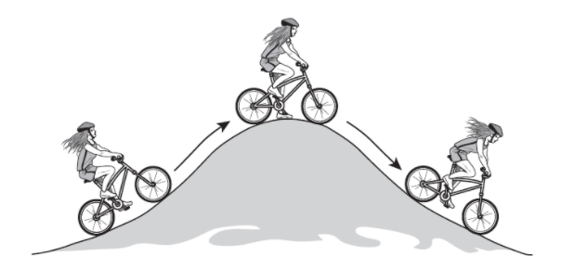Sound Energy
4. Chemical Energy
5. Light Energy
6. Which type of energy was **NOT** produced by Sam when riding the bike?
7. Kinetic Energy
8. Light Energy
9. Sound Energy
10. Heat Energy
11. Why was it harder for Sam to ride up the hill?
12. Sam’s gravitational potential energy is increasing.
13. The pull of gravity on Sam is increasing
14. Air is denser
15. Higher temperatures
16. An example of a device that transforms chemical energy to electrical energy is a
17. torch battery
18. hair dryer
19. pedestal fan
20. microwave
21. Which of the following does not influence the amount of gravitational potential energy an object has:

a) mass

b) velocity  
c) height above ground  
d) gravitational pull

1. Energy is measured in:  
    a) Kilograms  
    b) Metres  
    c) Joules  
    d) Litres
2. Which of the following devices converts gravitational potential energy to kinetic energy?
3. Battery
4. Playground slide
5. Bow and arrow
6. Car
7. Which type of energy is contained in food?

a) Chemical  
 b) Solar  
 c) Nuclear  
 d) Thermal

1. Which one of the following inventions converts sunlight energy into electricity?

a) Photovoltaic cells.

b) Compact fluorescent lights.

c) Incandescent lights.  
d) Light emitting diodes.

**END OF MULTIPLE-CHOICE SECTION**



**SEMESTER ONE 2023**

**ENERGY**

**ANSWER BOOKLET**

**NAME:**

**FORM:** **DATE:**

Multiple Choice Short Answer Total

**/55**

**/10**

**/45**

**SECTION ONE:** Multiple choice answers

Cross (X) through the correct answer.

|  |  |  |  |  |
| --- | --- | --- | --- | --- |
| **1** | a | b | c | d |
| **2** | a | b | c | d |
| **3** | a | b | c | d |
| **4** | a | b | c | d |
| **5** | a | b | c | d |
| **6** | a | b | c | d |
| **7** | a | b | c | d |
| **8** | a | b | c | d |  |
| **9** | a | b | c | d |  |
| **10** | a | b | c | d |  |

**Section Two - Short Answer Section** *(Must questions)* **(42 marks)**

1. Calculate the energy required in the following situations using the formulas provided. (5 marks)
2. Calculate the gravitational potential energy for the following:

$$Gravitational PE=mass × gravitational pull × height above ground$$

|  |  |  |  |  |
| --- | --- | --- | --- | --- |
| Situation | Mass | Gravitational pull | Height above ground | Gravitational PE |
| Car at the top of a hill | 1500 kg | 9.8 m/s2 | 50 m | J |
| Person standing on a cliff | 55 kg | 9.8 m/s2 | 150 m | J |

1. Calculate the kinetic energy for the following:

$$Kinetic Energy= \frac{1}{2} × mass × velocity × velocity$$

|  |  |  |  |
| --- | --- | --- | --- |
| Situation | Mass | Velocity | Kinetic energy |
| Student running for the bus | 60 kg | 2 m/s | J |
| Person riding a scooter | 100 kg | 4 m/s | J |

1. **Draw** an **Energy Flow Diagram** for the following and circle if it is an energy transfer or transformation: (6 marks)  
   a. Television speakers:  
     
    Electrical Energy 🡪

Transfer or Transformation

b. A golf club hitting a golf ball

Transfer or Transformation

🡪

c. Consuming food:

Transfer or Transformation

🡪

1. **Identify** the following as either **potential** or **kinetic** energy: (8 marks)

**Gravitational, sound, nuclear, elastic, heat, chemical, light, electrical**

|  |  |
| --- | --- |
| **Potential Energy** | **Kinetic Energy** |
|  |  |

1. **State** the Law of conservation of energy. **Provide** an **example** of a waste energy that can be released when energy transformation occurs. (2 marks)

________________________________________________________________________________  
  
________________________________________________________________________________

________________________________________________________________________________

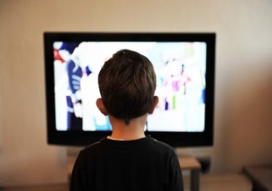

*(Should Questions)*

1. Michael watches a television show after school.

1. State the source of energy for the television. (1 mark)

**­­­­**

1. List three forms of energy that this energy transformed into. (3 marks)

________________________ _________________________ _______________________

1. Can a television be 100% efficient? (Circle the correct response). (1 mark)

YES NO

1. Using your answer in part (c), **describe** why do you think so? (3 marks)

________________________________________________________________________________________________________________________________________________________________________________________________________________________________________________

1. Brittney is looking at buying a fridge for her new house. She is wanting to find the most efficient fridge to reduce her power bill. Below is information for one of the fridges that Brittney has been looking at the LG Stainless Steel Side by Side.

|  |  |
| --- | --- |
| LG 655L Side by Side Fridge in Stainless Finish, front open food view, GS-B655PL | The LG Stainless Steel fridge can receive 5000J of electrical energy and convert that to 3300J of kinetic energy. |

1. Calculate the amount of waste energy produced. (1 mark)

________________________________________________________________________________

1. Define waste energy and explain what one of the forms of waste energy is in this situation. (3 marks)

________________________________________________________________________________

________________________________________________________________________________

________________________________________________________________________________

1. Calculate the efficiency of the LG Stainless Steel fridge using the formula below. (3 marks)

$$Efficiency= \frac{Output energy}{Input energy} ×100$$

________________________________________________________________________________

________________________________________________________________________________

________________________________________________________________________________

*(Could questions)*

1. Below is a diagram of a rollercoaster:

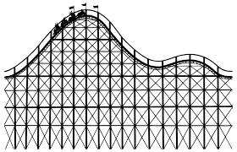

1. Label the point on the rollercoaster where there will be the **most** potential energy with the letter **A.** (1 mark)
2. Label the point on the rollercoaster where there will be the **most** kinetic energy with the letter **B.** (1 mark)
3. Label the point on the rollercoaster where there will be **equal** kinetic and potential energy with the letter **C.** (1 mark)
4. Solar panels are a collection of solar cells. Describe the method of energy transfer involved in a solar panel. (2 marks)

________________________________________________________________________________________________________________________________________________________________________________________________________________________________________________________________________________________________________________________________

1. Explain how solar cars are more efficient than petrol cars in regard to energy being transferred and transformed. (3 marks) ________________________________________________________________________________________________________________________________________________________________________________________________________________________________________________________________________________________________________________________________________________________________________________________________________________
2. Nuclear power would be an effective way to produce electricity in Australia. Identify one hazard associated with Nuclear Power Plants. (1 marks)

________________________________________________________________________________

**END OF TEST**